# Overview

The Design Rationale is intended to provide designers and maker information about the design process and design decisions behind the development of the Adaptive Utensils, a set of adjustable and interchangeable 3D printed adaptive utensil handles.

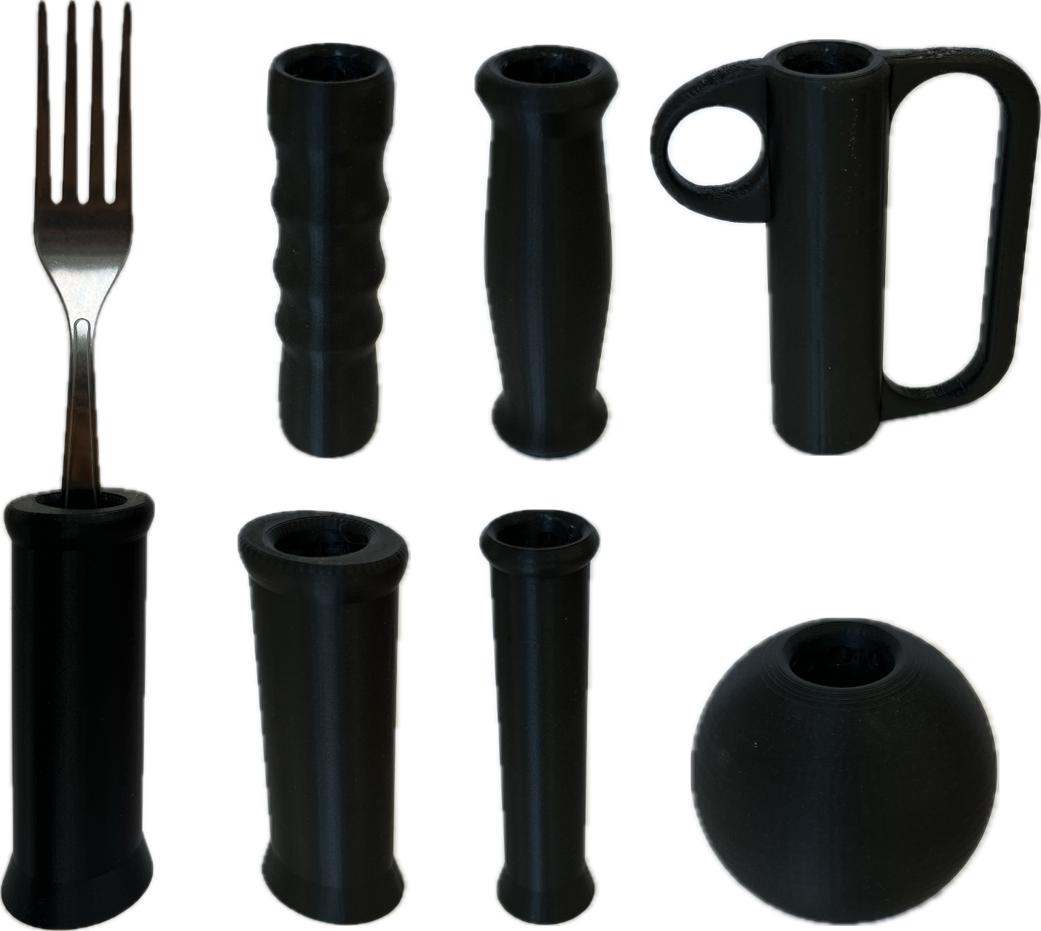

Contents

Overview 1

Introduction 4

Requirements 4

Goals 4

Functional Requirements 4

Non-functional Requirement 4

Constraints 5

Research 6

Commercially Available Options 6

Special Supplies Adaptive Utensils 6

Vincere Silverware Weighted Utensils 7

Special Supplies Bendable Adaptive Utensils 8

DIY / Maker-Friendly Options 8

Fork and Spoon Support 8

Universal hand grip for cutlery 9

Ideation 10

Ideation Decisions 11

Conceptual Designs 11

Core Mechanism (ID03) 11

Physical Component / Enclosure 12

Concept Decisions 13

Prototyping 14

GRH 2-Part Core (AU Rev01) 14

Physical Component / Enclosure 14

IKEA Hinged Core (AU Rev02) 15

Physical Component / Enclosure 15

Prototype Decisions 16

Testing 17

Test Methods 17

GRH 2-Part Core First Demo (TEST 1.1) 17

IKEA 2-Part Core First Demo (TEST 2.1) 17

IKEA 2-Part Core Second Demo (TEST 2.2) 17

IKEA 2-Part Core Third Demo (TEST 2.3) 17

Test Results 17

Detailed Design 19

Physical Component / Enclosure 19

Opportunities for Improvement 24

Physical Component / Enclosure 24

# Introduction

Commercially available adaptive utensils are expensive commitments where buyers are unable to trial different styles of handles and determine what best suits their needs. Some purchased sets cannot be returned, which may leave individuals with adaptive utensils that are uncomfortable to use.

The 3D printed Adaptive Utensils play the same role as commercially available adaptive utensils, which is to allow individuals with poor fine motor control to eat independently. However, the 3D printed handles fulfill a different niche in how they are fast and cheap to manufacture, which lowers the barrier-to-entry and lets individuals trial different handle shapes to develop their own preference. Afterwards, users may 3D print more of their preferred handle or purchase a similar commercial adaptive utensil set for long-term usage.

The 3D printed Adaptive Utensils are for individuals who struggle to grasp and manipulate utensils. The affected patient population includes weakness in arm or grip strength, tremors/shakiness, limited range of motion, and poor fine motor skills.

# Requirements

The goals and requirements outlined here can be used to assess if a device would meet the needs of a user and determine when a design is sufficient for release.

## Goals

|  |  |
| --- | --- |
| G01 | Handles must be significantly larger than a typical utensil handle and feel ergonomic to hold to reduce the strain on fingers |
| G02 | Must be compatible with at least a spoon and fork. |
| G03 | There should be as few components as possible to reduce the risk of misplacing them |
| G04 | Handles should be simple and quick to order/manufacture |

## Functional Requirements

|  |  |
| --- | --- |
| F01 | Utensil must be interchangeable with different types of handles |
| F02 | Adjustable depth for utensil in handle |
| F03 | Adjustable rotation for utensil in handle |
| F04 | Utensil must lock in place during regular usage |

## Non-functional Requirement

|  |  |
| --- | --- |
| NF01 | Create smooth geometry where possible to improve the overall appearance and feel of the printed handles |
| NF02 | Imitate common shapes for commercial adaptive utensils so users can test those styles before buying them |

## Constraints

|  |  |
| --- | --- |
| C01 | Printed handle sets must be cheaper than generic commercial adaptive utensils (maximum $30 CAD per set) |
| C02 | Use PLA and/or PETG, as they are the most common 3D printing materials |

# 

# Research

In 2022, two occupational therapists (OTs) at the Glenrose Rehabilitation Hospital brought up a problem to the Research and Innovation department about patients being unable to test different types of adaptive utensils before committing to buying them. In the current state, most patients have no experience or preference with adaptive utensils, and therapists have little information to determine if an adaptive utensil would help and which type would be the best option for their patient.

Thus, to allow patients to test various adaptive utensils for themselves, a project was started to develop cheap 3D printed Adaptive Utensils. The 3D printed handles should act as commercial adaptive utensils but should be cheap to manufacture and primarily act as a trial option before opting to buy a commercial set. To help the testing process, the handles should be compatible with a standard type of utensils, which should be quick to swap and adjust within each handle.

## Commercially Available Options

Options that can be purchased but not made by a maker.

### Special Supplies Adaptive Utensils

|  |  |
| --- | --- |
| **Title / Name of device** | Special Supplies Adaptive Utensils (4-Piece Kitchen Set) Wide Non-Weighted Non-Slip Handles for Hand Tremors Arthritis Parkinson's or Elderly use | Stainless Steel Knife Fork Spoons - Grey |
| **Link** | [Amazon Link](https://www.amazon.ca/Adaptive-Utensils-Non-Weighted-Arthritis-Parkinsons/dp/B074JH1T1N/ref=sr_1_27?dib=eyJ2IjoiMSJ9.PJDv_ZfCaUMWVva-WQ0olugQAISz270ZttgC0zVRIEUPbaWm91KhoN17TIkC6lInZaXvbG_51KgkctXPIbHhxGrnxEhV7Je4-uL4ZBbmjpAgnnmIei_QxQQvH58Wgm4aWhyRXKOaK-J4IiLRelmHG7ZU1KJ87vRul5jBZ_ofvw53E8ojedDs4tOcC-UxwwmU3Yai_wui3LA36y6WFVHRgvV47c2JPd6mJLm_S9I0CykyFGstleL030HGCs9uNqFMmJMj4ZHEpk2TZBNQgrUc8Rr6am4_Xs1cREyh53Ht2iY.ywIiCDyRfWxvzh3t0GBs88Ywei4UicXx_3RrFDgwdno&dib_tag=se&qid=1732038735&refinements=p_72%3A11192170011&rnid=11192166011&s=hpc&sr=1-27) |
| **Author** | Brand: Special Supplies. Distributor: Amazon |
| **License** | N/A |
| **Cost** | $35.00 CAD |

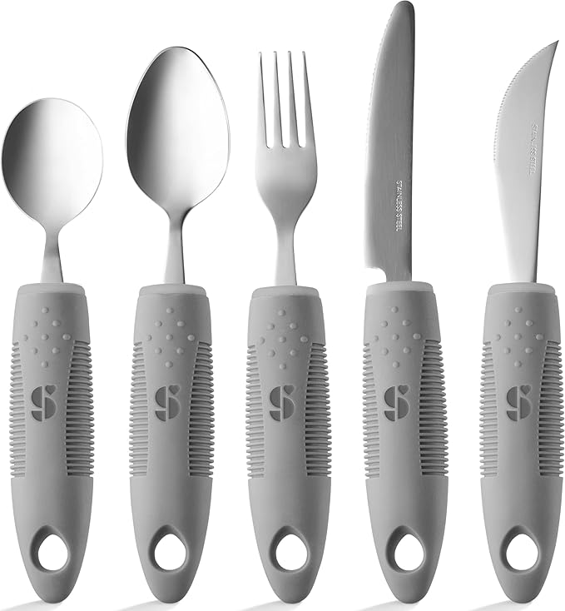

Non-weighted adaptive utensils that are dishwasher safe, have stainless-steel utensils, and ribbed silicone handles for improved grip. Each set includes a fork, knife, curved knife, dinner spoon, and soup spoon.

|  |  |
| --- | --- |
| **Requirements Met** | **Requirements Unmet** |
| G01, G02, G03, G04, F04, NF01 | F01, F02, F03, NF02 |

#### Useful Design Features

Utensils are dishwasher safe, which makes cleaning quick and easy.

### Vincere Silverware Weighted Utensils

|  |  |
| --- | --- |
| **Title / Name of device** | Weighted Utensils for Tremors and Parkinsons, Heavy Weight Stainless Steel Silverware Set, Adaptive Eating Flatware Helps Hand Tremors, Parkinsons Aids for Living, Arthritis - Knife, Fork, Spoons, 7oz |
| **Link** | [Amazon Link](https://www.amazon.ca/Weighted-Utensils-Tremors-Parkinsons-Silverware/dp/B07YNSJDW6/ref=sr_1_4?dib=eyJ2IjoiMSJ9.PJDv_ZfCaUMWVva-WQ0olugQAISz270ZttgC0zVRIEUPbaWm91KhoN17TIkC6lInZaXvbG_51KgkctXPIbHhxGrnxEhV7Je4-uL4ZBbmjpAgnnmIei_QxQQvH58Wgm4aWhyRXKOaK-J4IiLRelmHG7ZU1KJ87vRul5jBZ_ofvw53E8ojedDs4tOcC-UxwwmU3Yai_wui3LA36y6WFVHRgvV47c2JPd6mJLm_S9I0CykyFGstleL030HGCs9uNqFMmJMj4ZHEpk2TZBNQgrUc8Rr6am4_Xs1cREyh53Ht2iY.ywIiCDyRfWxvzh3t0GBs88Ywei4UicXx_3RrFDgwdno&dib_tag=se&qid=1732038735&refinements=p_72%3A11192170011&rnid=11192166011&s=hpc&sr=1-4) |
| **Author** | Brand: Vincere Silverware. Distributor: Amazon |
| **License** | N/A |
| **Cost** | $99.95 CAD |

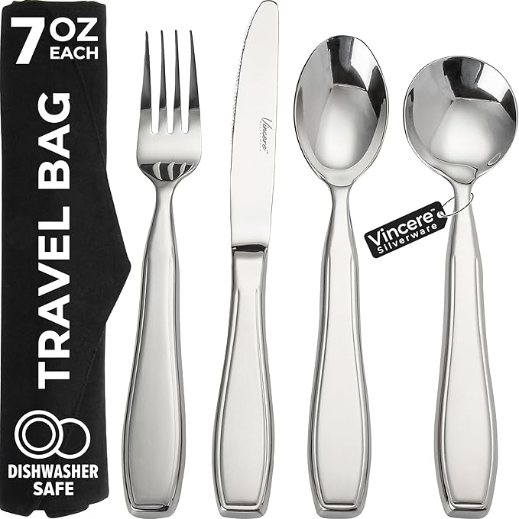

7oz weighted utensils designed to improve stability for individuals with tremors. They are dishwasher safe, but do not have a significantly larger handle like typical adaptive utensils. Each set includes a knife, fork, tablespoon, and soup spoon.

|  |  |
| --- | --- |
| **Requirements Met** | **Requirements Unmet** |
| G02, G03, G04, F04, NF01 | G01, F01, F02, F03, NF02 |

#### Useful Design Features

The weighted design should help reduce shaky hands from tremors.

### Special Supplies Bendable Adaptive Utensils

|  |  |
| --- | --- |
| **Title / Name of device** | Special Supplies Adaptive Utensils (4-Piece Kitchen Set) Wide Weighted Non-Slip Handles for Hand Tremors Arthritis Parkinson‚ or Elderly use | Stainless Steel Knife Fork Spoons (Gray Weighted Bendable) |
| **Link** | [Amazon Link](https://www.amazon.ca/Adaptive-Utensils-Weighted-Arthritis-Parkinsons/dp/B07JCF9HW3/ref=sr_1_16?dib=eyJ2IjoiMSJ9.PJDv_ZfCaUMWVva-WQ0olugQAISz270ZttgC0zVRIEUPbaWm91KhoN17TIkC6lInZaXvbG_51KgkctXPIbHhxGrnxEhV7Je4-uL4ZBbmjpAgnnmIei_QxQQvH58Wgm4aWhyRXKOaK-J4IiLRelmHG7ZU1KJ87vRul5jBZ_ofvw53E8ojedDs4tOcC-UxwwmU3Yai_wui3LA36y6WFVHRgvV47c2JPd6mJLm_S9I0CykyFGstleL030HGCs9uNqFMmJMj4ZHEpk2TZBNQgrUc8Rr6am4_Xs1cREyh53Ht2iY.ywIiCDyRfWxvzh3t0GBs88Ywei4UicXx_3RrFDgwdno&dib_tag=se&qid=1732038735&refinements=p_72%3A11192170011&rnid=11192166011&s=hpc&sr=1-16&th=1) |
| **Author** | Brand: Special Supplies. Distributor: Amazon |
| **License** | N/A |
| **Cost** | $33.40 CAD |

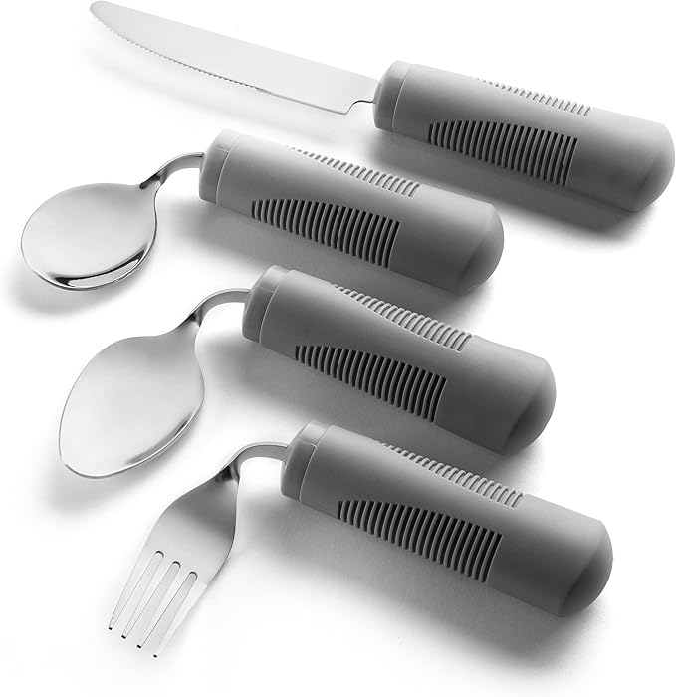

6oz weighted adaptive utensils that are dishwasher safe, have bendable stainless-steel utensils, and ribbed silicone handles for improved grip. Each set includes a fork, knife, dinner spoon, and soup spoon.

|  |  |
| --- | --- |
| **Requirements Met** | **Requirements Unmet** |
| G01, G02, G03, G04, F03, F04, NF01 | F01, F02, NF02 |

#### Useful Design Features

Utensils are bendable for more user customizability.

## DIY / Maker-Friendly Options

Options that can be made by a maker.

### Fork and Spoon Support

|  |  |
| --- | --- |
| **Title** | **Fork and Spoon Support** |
| **Link** | [Makers Making Change Link](https://www.makersmakingchange.com/s/product/fork-and-spoon-support/01tJR00000068zYYAQ) |
| **Author** | MMC Community |
| **License** | Attribution-NonCommercial-ShareAlike4.0 International |
| **Cost** | $0-$10 CAD |
| **Test Build (Y/N)** | N |
| **Add to Library (Y/N)** | Already Added |

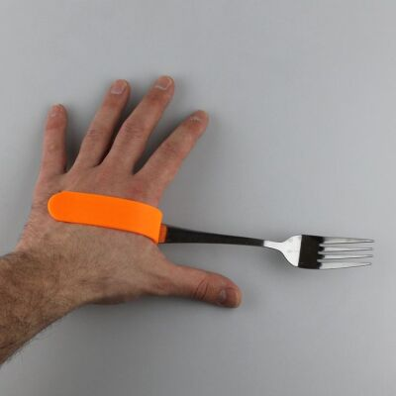

The Fork and Spoon Support allows people with limited grip strength to hold and use eating utensils. Users can slot the device over their palm for a grip-free usage or hold both handles for a larger grip. The slot fits standard sized eating utensils like forks, spoons, and knives.

|  |  |
| --- | --- |
| **Requirements Met** | **Requirements Unmet** |
| G01, G02, G03, G04, F02, F04, NF01 | F01, F03, NF02 |

#### Useful Design Features

Compatible with a wide variety of utensils. Clips around the hand and does not require individuals to grip anything.

### Universal hand grip for cutlery

|  |  |
| --- | --- |
| **Title** | Universal hand grip for cutlery |
| **Link** | [Thingiverse Link](https://www.thingiverse.com/thing:686084) |
| **Author** | Pole_ergo |
| **License** | Creative Commons – Attribution – Non-commercial 4.0 International |
| **Cost** | $0-$10 CAD |
| **Test Build (Y/N)** | N |
| **Add to Library (Y/N)** | N |

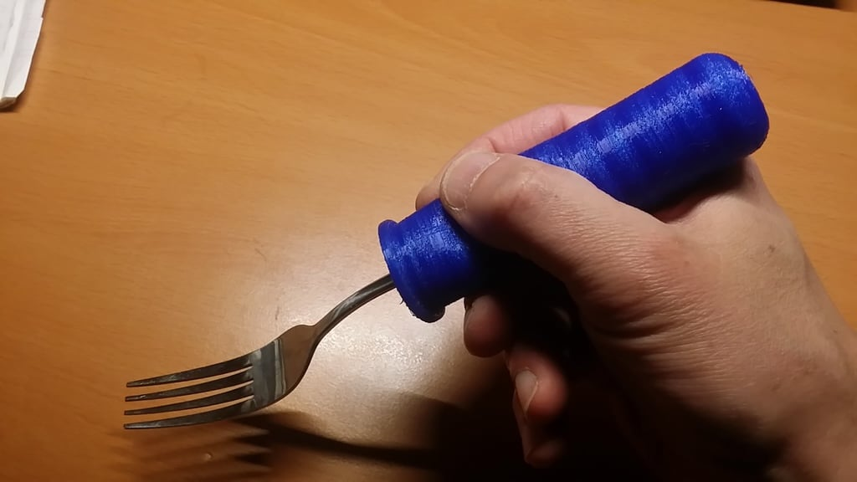

3D printed handle for flat metal fork/spoon/knife. Must be printed in a soft material like Ninjaflex, where infill density will affect the overall rigidity of the handle.

|  |  |
| --- | --- |
| **Requirements Met** | **Requirements Unmet** |
| G01, G02, G03, G04, F02, F04, NF01 | F01, F03, NF02 |

#### Useful Design Features

Soft material makes the handle compatible with a wide variety of utensil handles and makes the outer shell conform to the user’s grip.

# Ideation

**Epoxy Assembly (ID01):** 3D print 2 halves of each adaptive handle with a slot cut out to fit the utensil. Insert the utensil between handle halves and use epoxy to affix all 3 parts together.

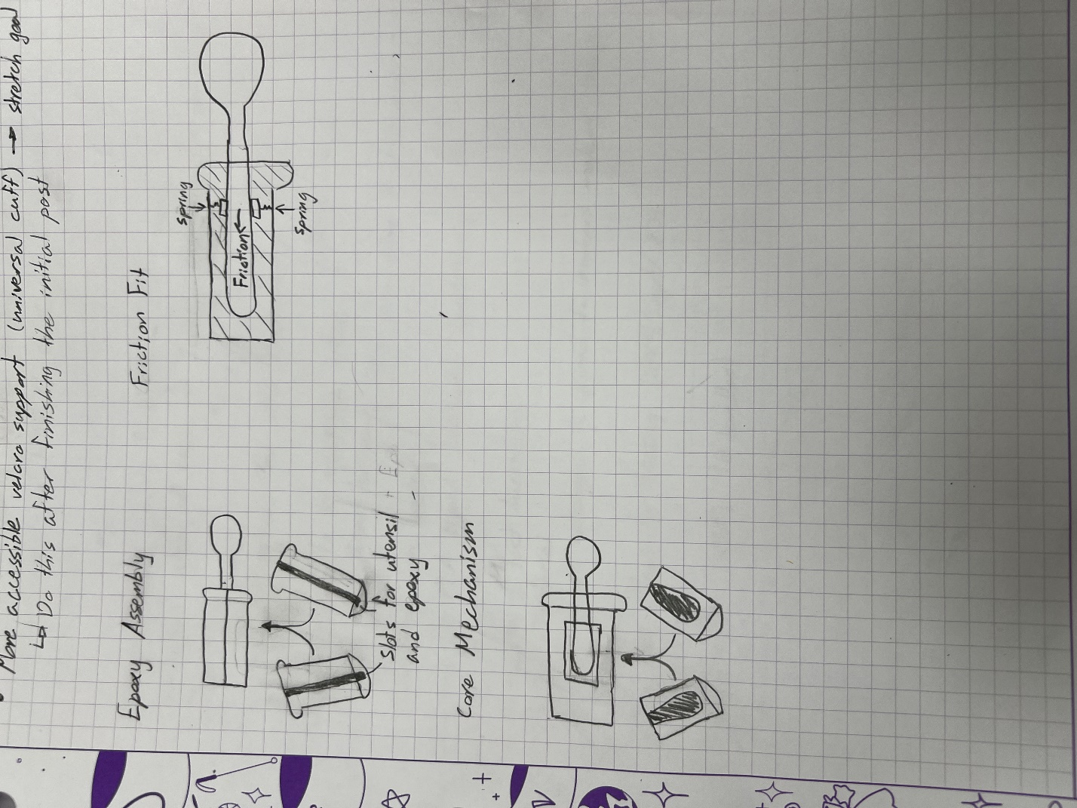

**Friction Fit (ID02):** Slide utensil into a 3D printed handle and lock in place with a friction fit. Similar idea as the DIY option above (Universal hand grip for cutlery).



**Core Mechanism (ID03):** 3D print core mechanism to clamp around the utensil, where the core can be inserted and locked into different 3D printed handles

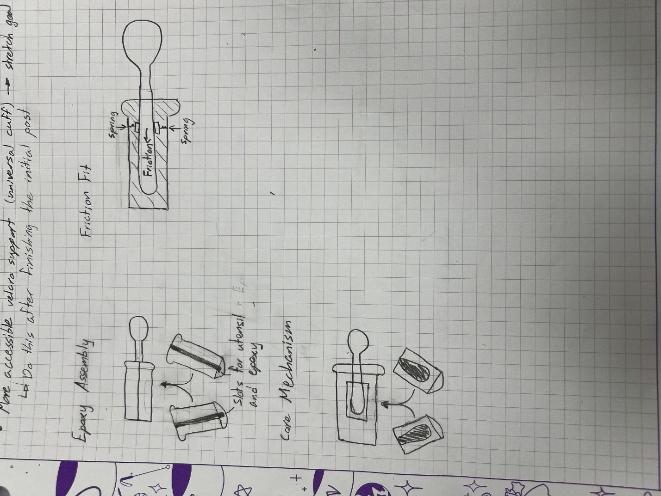

## Ideation Decisions

|  |  |  |
| --- | --- | --- |
| **Idea** | **Decision (Abandon, Modify, Proceed)** | **Justification** |
| Epoxy Assembly (ID01) | Abandon | Requires a utensil and significant assembly time for each handle that is made. Epoxy is permanent, which means the utensil cannot be removed and placed in a dishwasher. |
| Friction Fit (ID02) | Abandon | Does not offer much adjustability. Friction force is unreliable because the 3D prints will wear over time. |
| Core Mechanism (ID03) | Proceed | Clamping around a utensil handle will require some friction, but because the core will be a smaller part, it will be easier to replace if it wears down. A clamp is a non-permanent option so the utensil may be removed and placed in a dishwasher. The core assembly should be able to be inserted into each of the 3D printed handles while offering some adjustability and locking mechanism. |

# Conceptual Designs

## Core Mechanism (ID03)

Core mechanism to clamp around utensil and swap between 3D printed adaptive handles

### Physical Component / Enclosure

The utensils used for the initial concept were the standard Glenrose Rehabilitation Hospital cutlery because the original focus was for inpatients.

Because the base of the utensil handle is large and it tapers inwards moving towards the “eating end”, the utensil can be held by cutting a profile of the utensil into the core and clamping it shut. We created a clamping mechanism using two halves of a cylinder and a collar/shell that slides around everything to keep the core closed. To lock positioning, the core will have a compliant mechanism with a ball socket and the handles have corresponding hemisphere cutouts inside at various depths and rotations. When inserting the core into a handle, the ball is pressed inwards and is continuously exerting force to spring back outwards. When the ball socket is aligned with a hemisphere cutout, then the ball pushes out and locks the core assembly inside the handle.

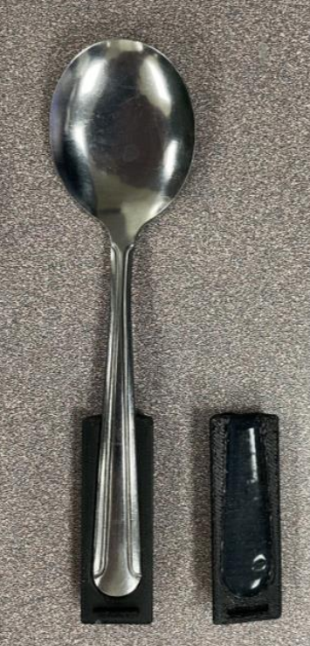 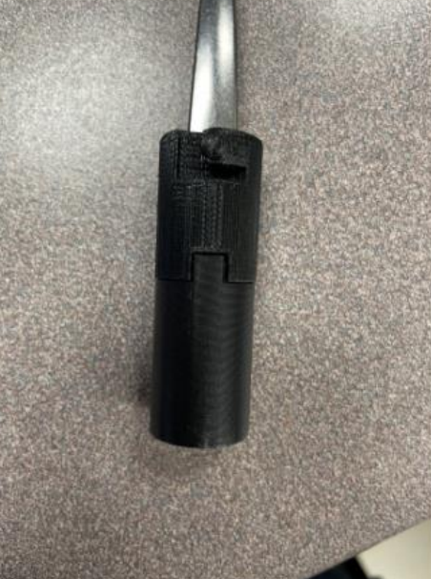 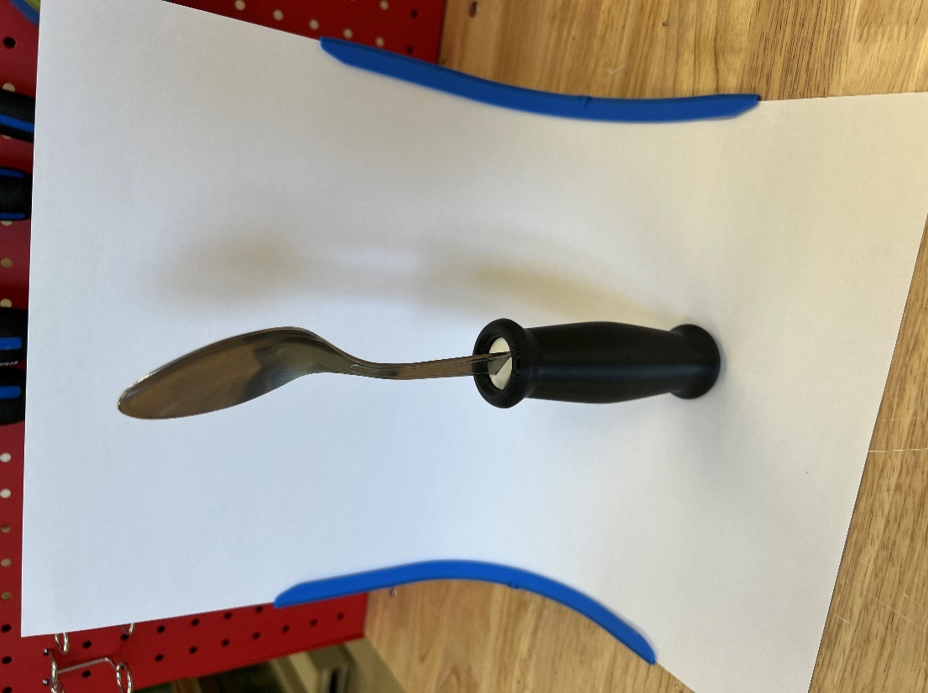

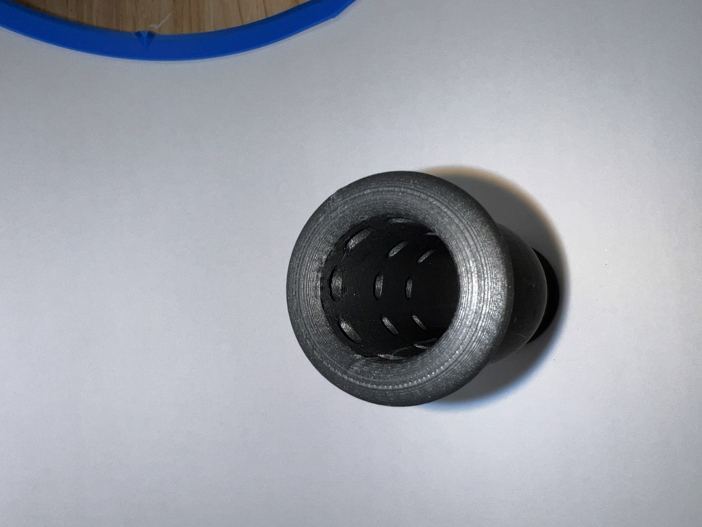

## Concept Decisions

|  |  |  |
| --- | --- | --- |
| **Concept** | **Decision (Abandon, Modify, Proceed)** | **Justification** |
| Core Mechanism (ID03) | Proceed | The core was promising because it was the only idea that could non-permanently hold the utensil without significant risk of wear over time. It also has the best potential for being: insertable, removable, have depth adjustment, have rotation adjustment, and be able to lock in position. Only having to swap the core between handles means that fewer utensils and less assembly time would be required to test out various types of handles. |

# Prototyping

## GRH 2-Part Core (AU Rev01)

2-part adaptive utensil cores designed for the standard Glenrose Rehabilitation Hospital cutlery.

### Physical Component / Enclosure

The utensils used for the first prototype (AU Rev01) were the standard Glenrose Rehabilitation Hospital cutlery because the original focus was for inpatients.

The 2-part cores are 2 halves of a cylinder with a tapered slot cut out to fit the base of the utensil and prevent it from sliding upwards out of the core. The cylinder is held shut by sliding a 3D printed shell around the cylinder halves.

We quickly realized that the core cutouts need to match as perfectly as possible with the utensil bases or else they would have too much wiggle room and fall out of the core. So, to produce a minimum viable product (MVP), we decided to reduce the development time by limiting the utensil options to a large spoon and fork.

As per the Core Mechanism idea (ID03), we made a compliant mechanism to lock the core into any of the 3D printed handles. Inside the handles, there are 3 rings of 8 hemisphere cutouts, for a total of 24 cutouts. When the core is inserted into a handle, the compliant mechanisms push outwards and lock in place when aligned with the hemisphere cutouts. This allows for 3 levels of depth adjustment in increments of 20mm and for 8 levels of rotation adjustment in increments of 45°.

There were 9 handles designed for this project: Straight-Small, Straight-Large, Finger Grip, Rounded Grip, Ellipse, Finger Support-Small, Finger Support-Large, Sphere-Small, and Sphere-Large. More details on the handle shapes, styles, and sizes can be found in the Detailed Design section.

The cores are printed out of PETG for more abrasion resistance and tolerance consistency. The handles are printed out of PLA for cost effectiveness and ease of manufacturing.

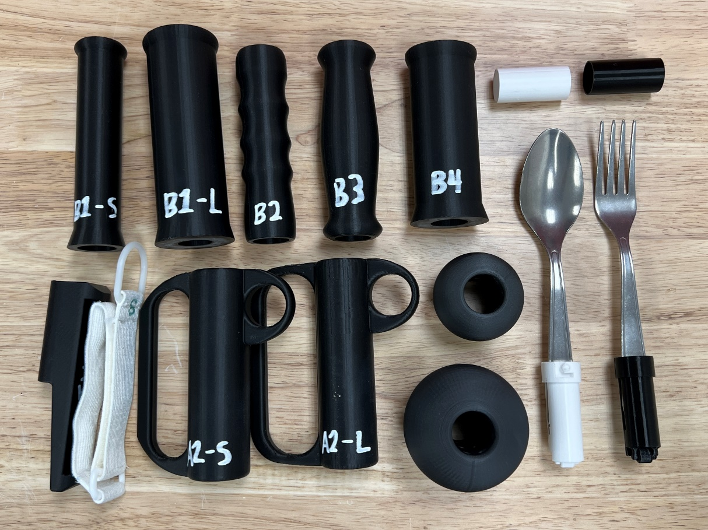 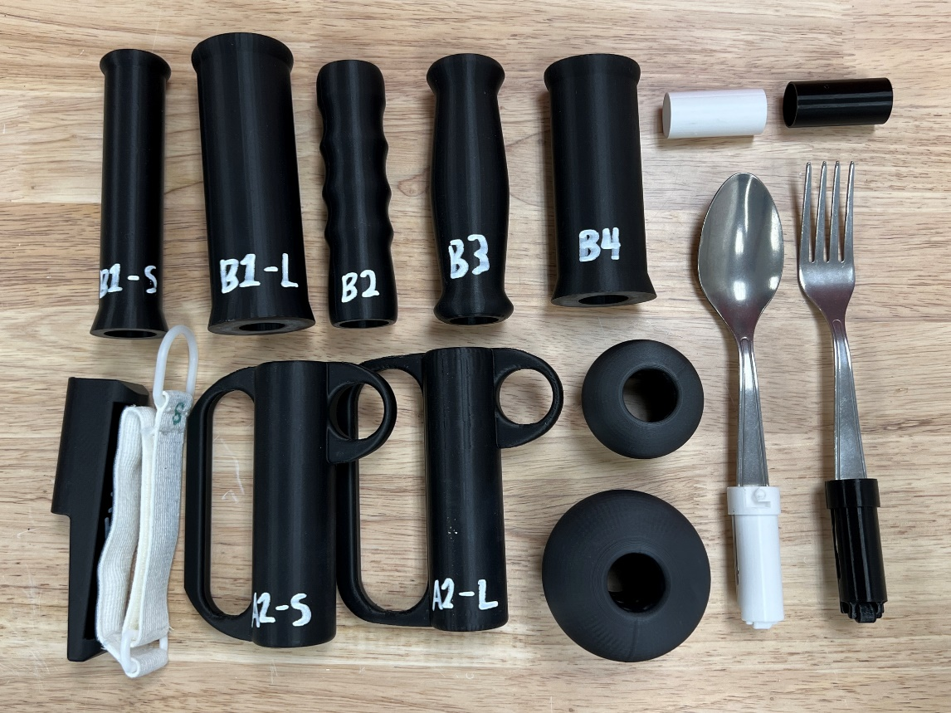

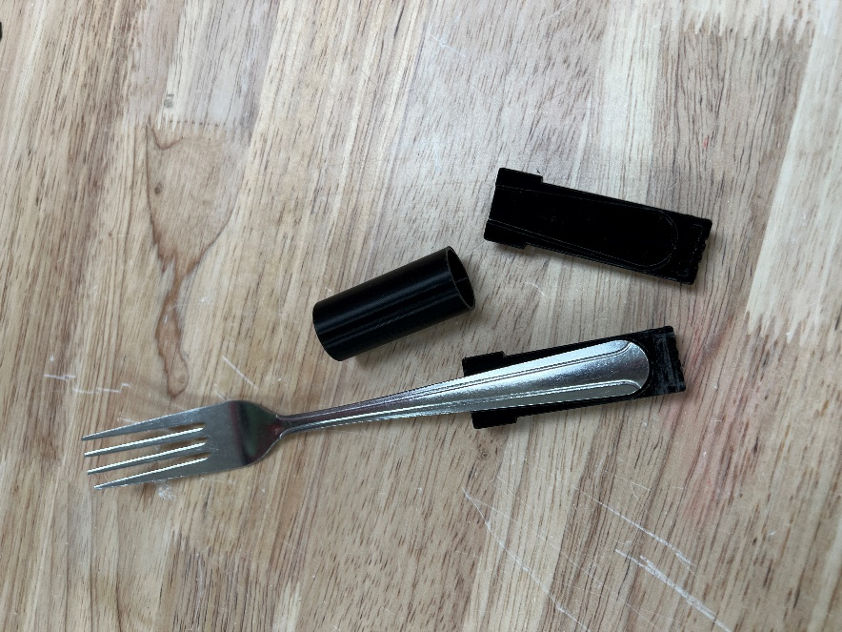 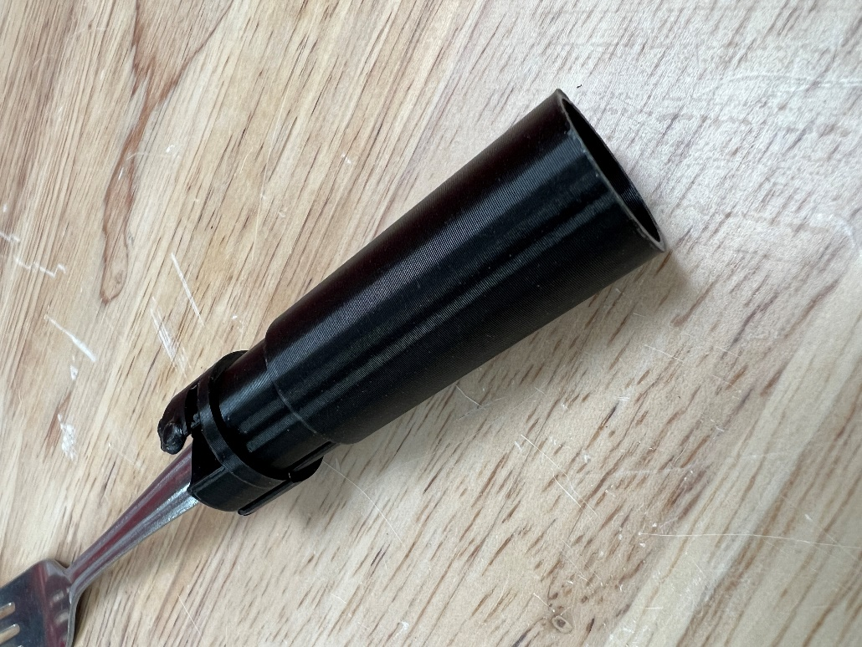 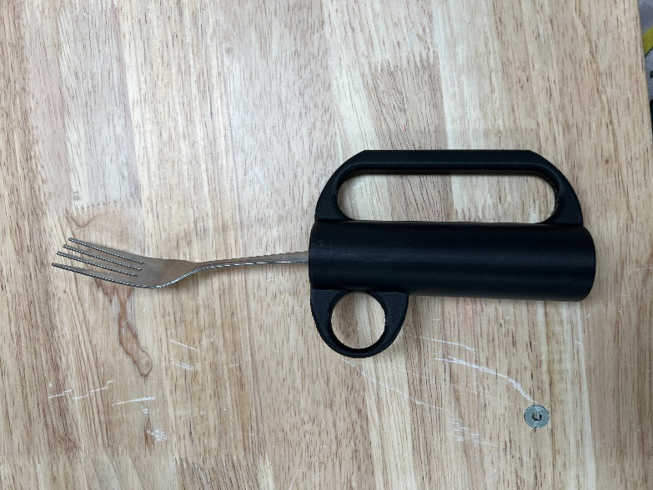

## IKEA Hinged Core (AU Rev02)

Adaptive utensil cores with a print-in-place hinge designed for the IKEA IDENTITET cutlery set.

### Physical Component / Enclosure

The utensils used for the second prototype (AU Rev02) were the IKEA IDENTITET cutlery because the focus has been shifted to public accessibility.

The core cylinder halves have been combined into one part by taking advantage of a print-in-place hinge. And to improve the core’s locking strength in the handle, a second ball socket was added on the opposite side of the core. The tapered slot cutout was adapted to the IKEA IDENTITET large spoon and fork, and in doing so, the 3D printed handles had to be upscaled to fit the larger cores for the new utensil profiles.

The hemisphere cutouts, handle types, and material choices remain unchanged from AU Rev01.

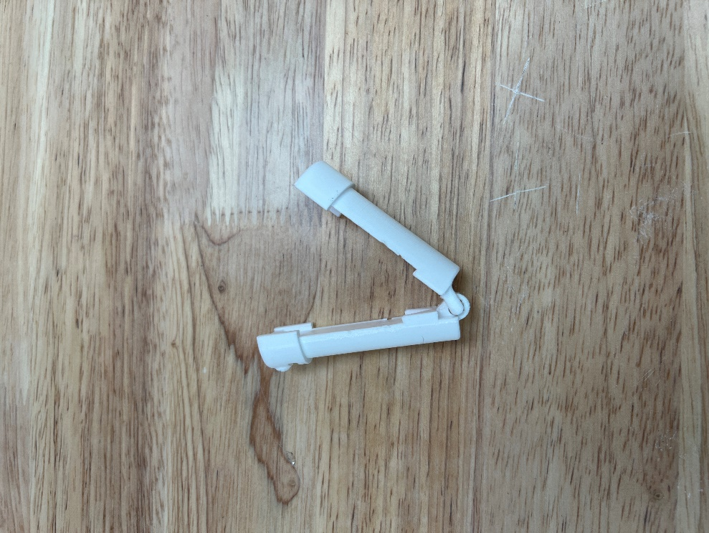 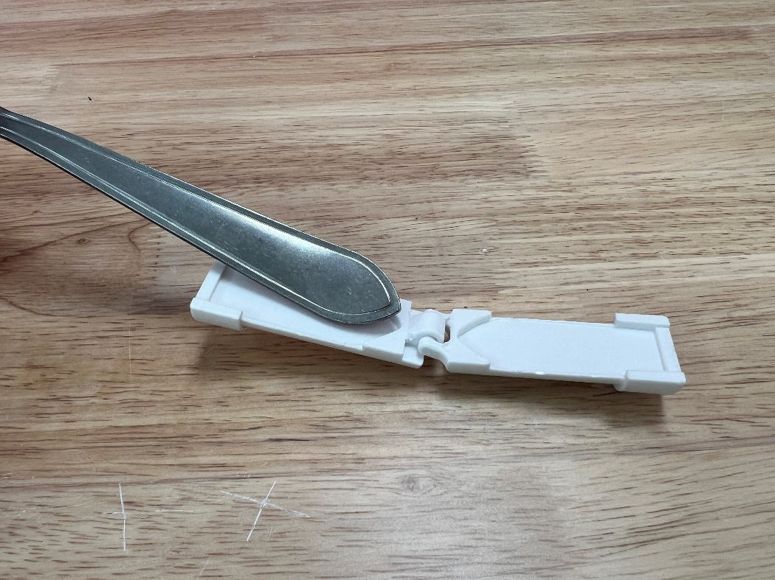

## Prototype Decisions

|  |  |  |
| --- | --- | --- |
| **Prototype** | **Decision (Abandon, Modify, Proceed)** | **Justification** |
| GRH 2-Part Core (AU Rev01) | Modify | The standard GRH utensils would be good for hospital use, but they are not accessible to the general public. In addition, the utensils were thin, which made it difficult to achieve a strong grip on them with the cores.  The cylinder halves that make up the core function as intended, but they add extra components that may be misplaced. The next prototype should try to consolidate the two parts into one using hardware, snap fits, living hinges, etc.  The locking sockets worked well, but the ball tips showed significant wear over time. To make a better hold, there should be a second ball socket placed opposite to the original one. This will double the locking strength and improve the core’s stability inside the handles. |
| IKEA Hinged Core (AU Rev02) | Proceed | Changing to IKEA IDENTITET utensils improves both accessibility and functionality. IKEA has nearly 500 stores worldwide and has a reputation of consistency to allow more makers to acquire the exact utensil set used for this build. Additionally, the IDENTITET utensil handles are wider and have a steeper taper (in comparison to the GRH utensils), which makes it easier for the core to grip the utensil base.  The cylinder halves are now combined to print as one part using a print-in-place hinge, which improves the overall ease of use.  There are now 2 locking sockets in the core mechanism. This improves the stability by adding another point of contact as well as increases the lifespan of the part by strengthening the lock. |

# 

# Testing

## Test Methods

The 3D printed Adaptive Utensils were only tested for useability by occupational therapists and patients, which is not repeatable. Each test below describes different periods of user testing and the resultant feedback to improve the device.

### GRH 2-Part Core First Demo (TEST 1.1)

The first prototypes (AU Rev01) of the 3D printed Adaptive Utensils were given to 2 occupational therapists for testing. This version was designed for the standard GRH cutlery, and the defining features were the 2-part half-cylinder cores.

After some testing, it was clear that the GRH utensils did not suit the use-case for this device. The utensils occasionally slipped out of the core due to their thin profile, which left the core stuck inside the handles. With the cores’ slot cutouts being dedicated to a specific utensil handle, it was a slight hinderance to find the matching cylinder halves for assembly.

### IKEA 2-Part Core First Demo (TEST 2.1)

The second prototypes (AU Rev02) were given to the same OTs for testing. This version was designed for the IKEA IDENTITET utensils and hosted the single-piece cores with print-in-place hinges.

With a new size, the tolerance between the cores and handles changed such that: the fits between certain handles varied slightly; the core shells occasionally got stuck inside certain handles when removing the core; and the cores did not lock within the handles during regular usage of the utensils.

### IKEA 2-Part Core Second Demo (TEST 2.2)

AU Rev02 was modified and underwent the same testing conditions. This version had improved tolerances and an improved core locking strength.

The changes drastically improved the consistency and ease of use. The next issue was that, since the handles have the same diameter hole cut through the whole length, some users may try to insert the cores in the wrong side of the handle.

### IKEA 2-Part Core Third Demo (TEST 2.3)

AU Rev02 was modified again and underwent the same testing conditions. This version had slightly closed off the bottom holes of each handle such that the core could not be inserted the wrong way.

In this testing session, the occupational therapists liked the new design and had no more suggestions for improvement.

## Test Results

For TEST 1.1, the primary critiques regarded the core assembly. The cores were unable to firmly hold the utensil bases due to the thin profile of the utensils. The separate cylinder halves added more time to organization and assembly. From TEST 1.1, the utensils were changed to the IKEA IDENTITET set for a thicker profile as well as for more accessibility outside of the hospital. Additionally, there was a print-in-place hinge added to the core such that each fork/spoon core prints as one piece and cannot be separated or mismatched.

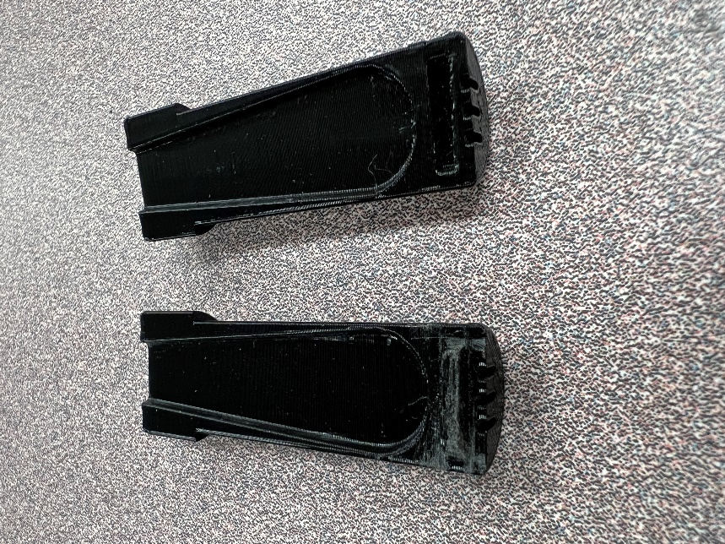 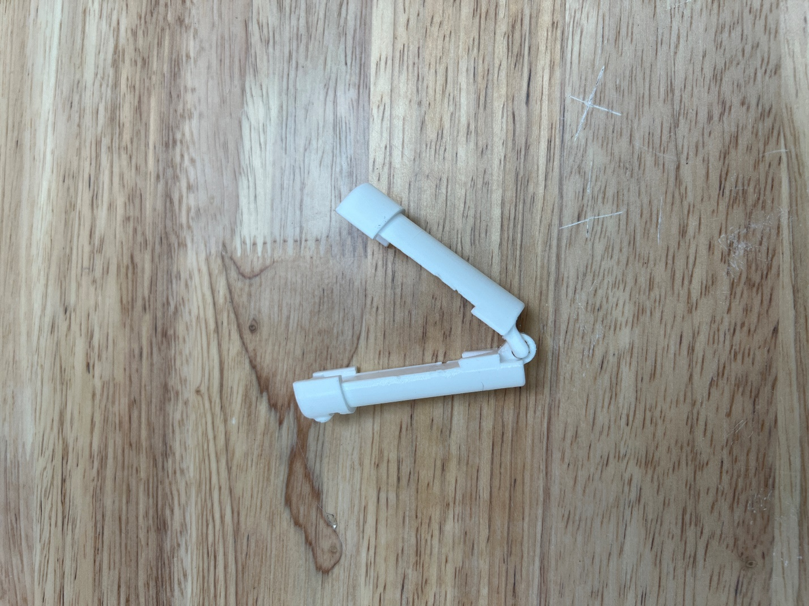

For TEST 2.1, the primary critiques regarded the tolerance. The fits were not uniform, and the core assemblies did not lock while still being easily removable. The handle models for AU Rev02 were tweaked to create a more universal fit with the core, and in doing so, the core shells no longer got stuck inside the handles. Then to create a stronger hold for the cores, a second ball socket was added to the opposite side to double the force pushing outwards in the hemisphere cutouts.

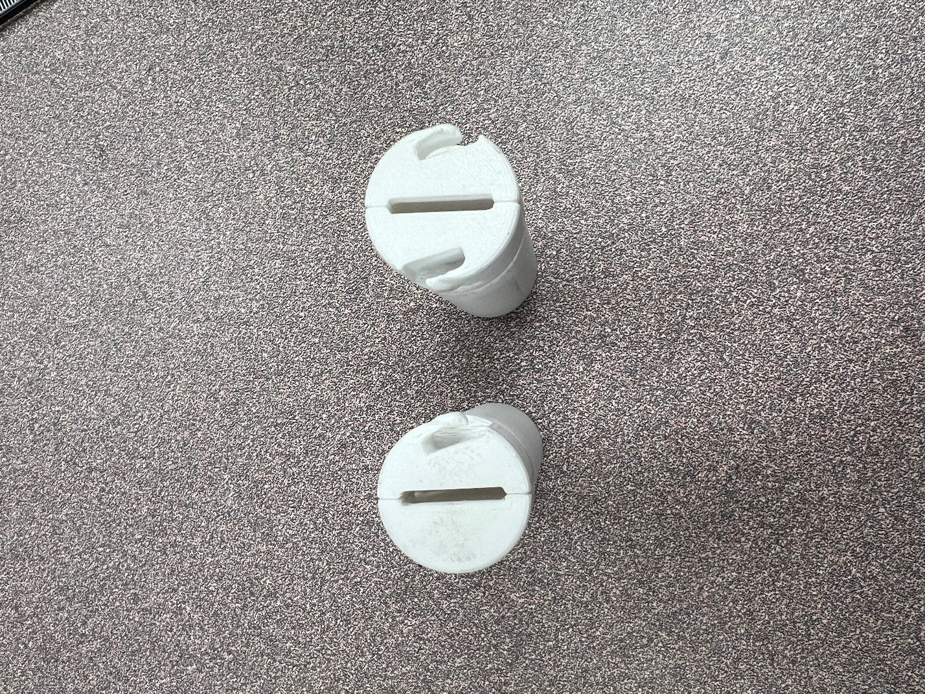

TEST 2.2 had positive feedback for all previous changes. The only issue from this testing period was about potential for misuse by inserting cores into the wrong side of the handles. Using the wrong side means that the locking mechanism would not work because the hemisphere cutout layers are positioned near the tops of each handle. To prevent this, the bottoms of each handle were slightly closed off such that the cores would not fit but were still open for cleaning access.

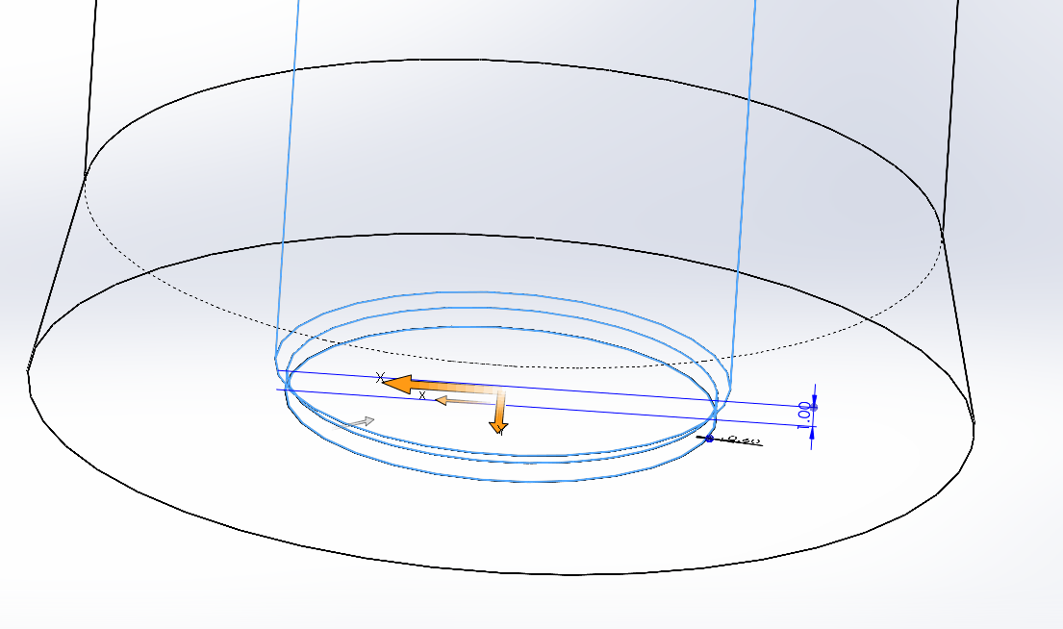

TEST 2.3 had positive feedback again. The OTs did not have any more feedback and stated that the project is ready for completion.

# Detailed Design

The 3D printed Adaptive Utensils consist of core assemblies to hold the IKEA IDENTITET utensils and various handles to lock the utensil cores in place at different depths and rotations.

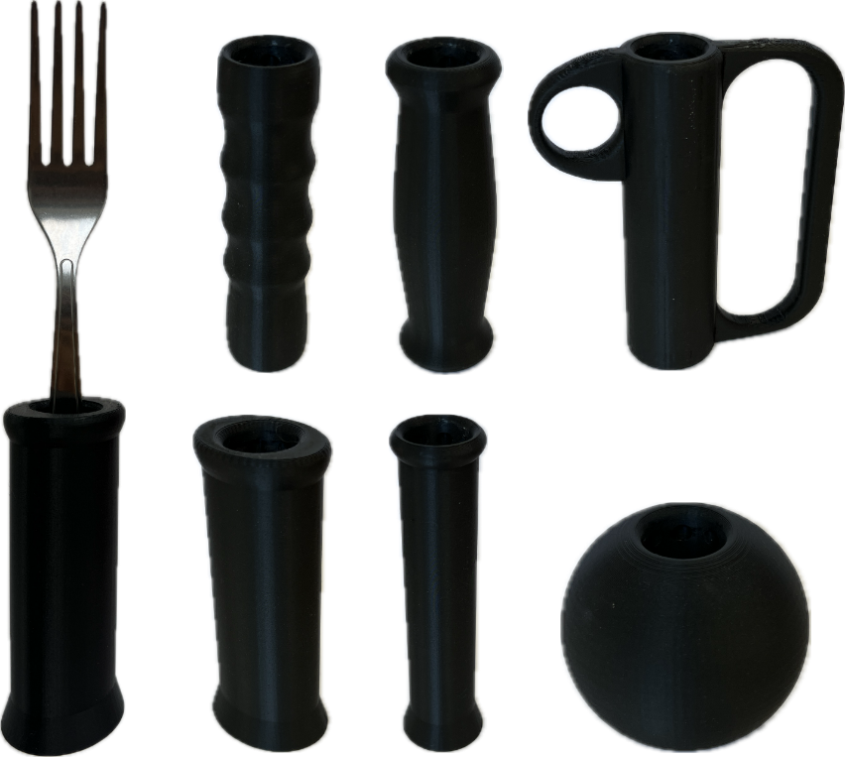

### Physical Component / Enclosure

The cores have 2 separate models with specific slot cutouts to hold the IKEA IDENTITET large spoon and fork profiles (G02). Separate colors help differentiate the core profiles, so the spoon core is commonly printed with white PETG and the fork core is commonly printed with black PETG. Otherwise, the core types can be labeled with a permanent marker.

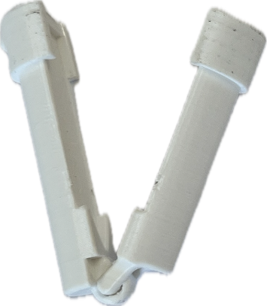 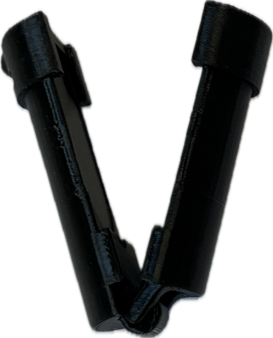

The core is designed to clamp around the utensil bases, where a separate shell slides around the core clamp to lock it closed. The 2 cylinder halves of the core clamp are designed with a print-in-place hinge to print as one part, which reduces assembly time as well as risk of misplacing pieces (G03). Both fork and spoon cores have a universal fit such that they are interchangeable between all of the 3D printed handles (F01).

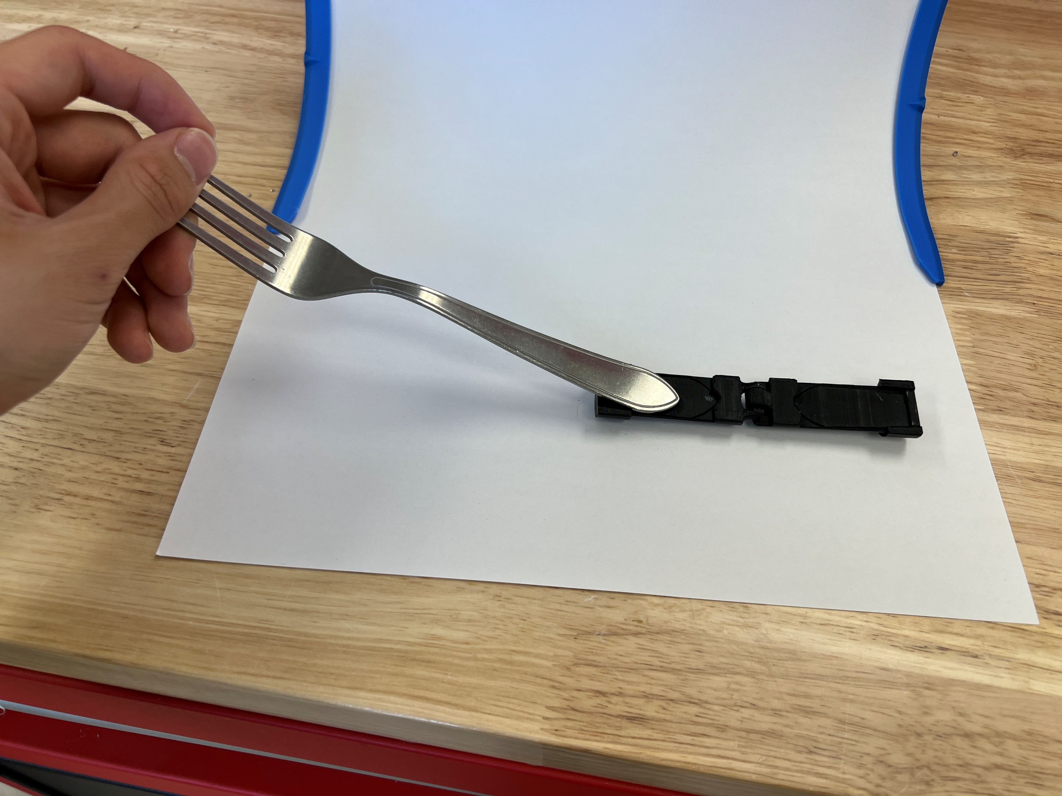

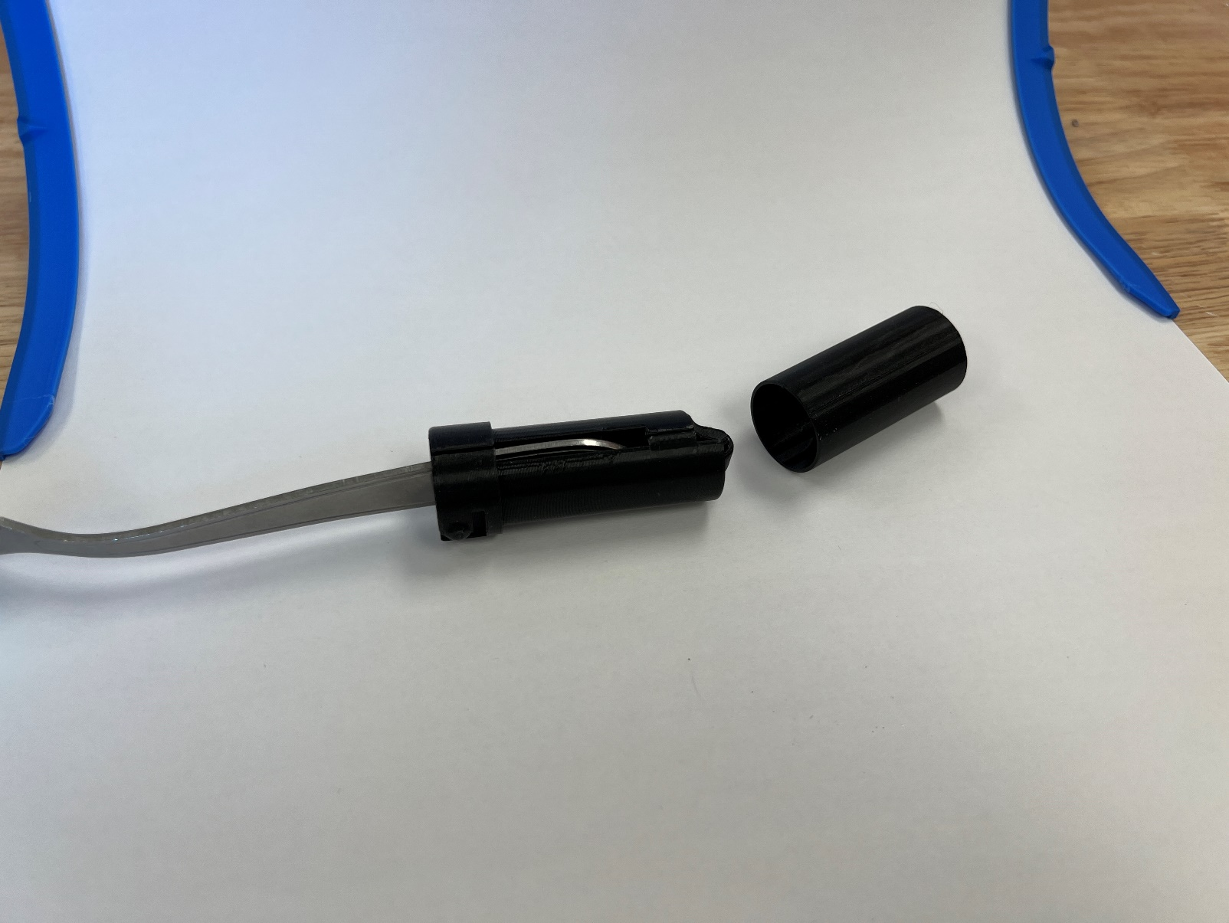

The core clamps have two locking ball sockets with compliant spring mechanisms to push outwards when inserted into the handles. There are 24 hemisphere cutouts inside each handle that allow the ball sockets to push outwards into the corresponding cavities, thus locking the core in place within the handle (F04). The cutouts are arranged in 3 rings of 8, which allow for 3 levels of depth adjustment in increments of 20mm (F02) and for 8 levels of rotation adjustment in increments of 45° (F03).

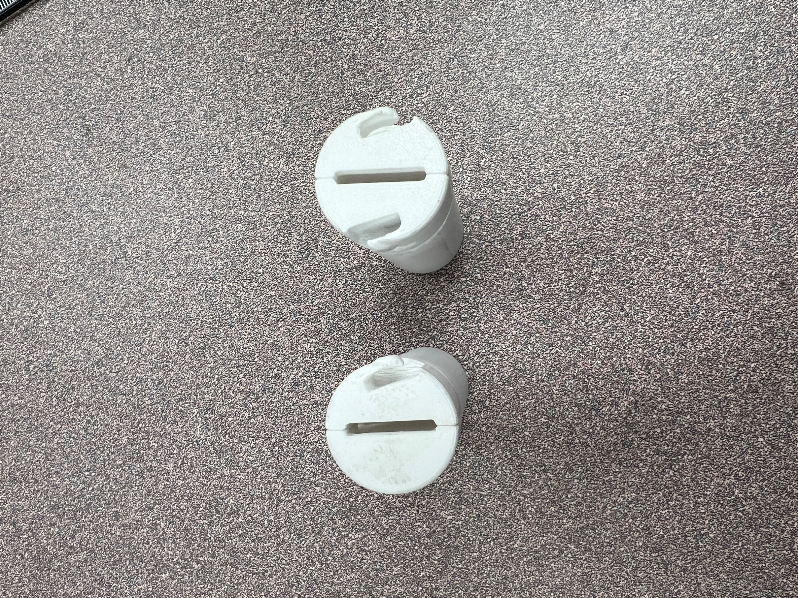 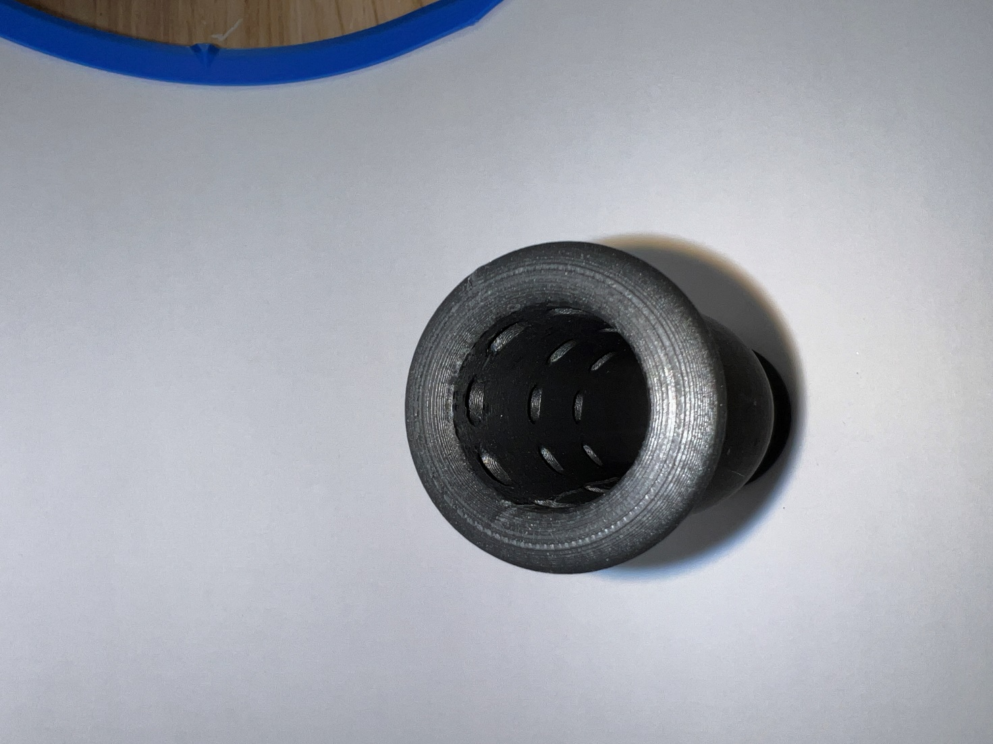

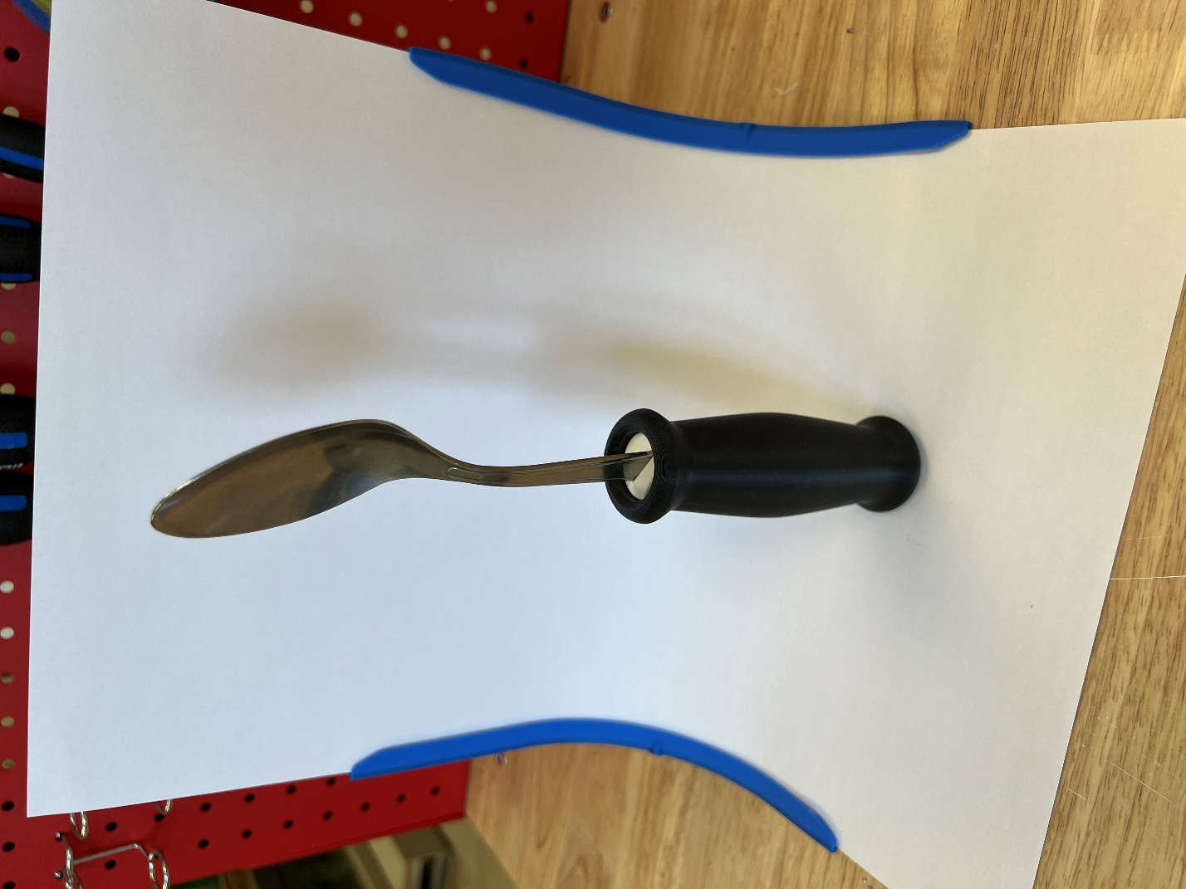 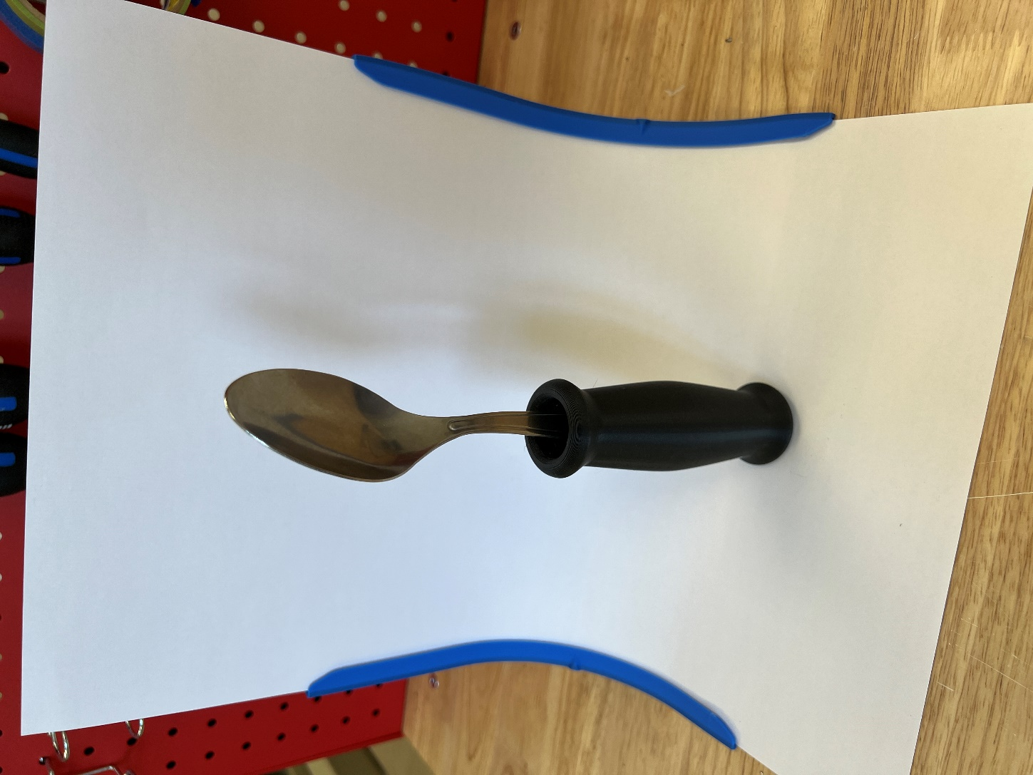

Each of the handles are printed with PLA filament, where they offer a larger area to grasp and feel ergonomic to hold (G01) due to their smooth geometry (NF01). Some handles mimic common shapes for commercial adaptive utensils (NF02), and others have more experimental shapes to explore the possibilities of 3D printing with adaptive utensils. The parts are easy to print due to the simple designs (G04). They are more accessible than commercially available adaptive utensils because they are 3D printable with common materials such as PLA and PETG (C02) and they are cheap (C01) due to a low upfront manufacturing cost.

There are 9 different types of handles for the 3D printed Adaptive Utensils:

* Ellipse
  + Cylinder handle with an oval cross section shape.
* Finger Grip
  + Handle with finger groove indentations.
* Finger Support-Large
  + Has rigid support around the fingers and thumb. The larger version has a 33mm spacing for the finger support.
* Finger Support-Small
  + Has rigid support around the fingers and thumb. The smaller version has a 27mm spacing for the finger support.
* Rounded Grip
  + Rounded handle that is thickest in the middle and tapers thinner at the top and bottom.
* Sphere-Large
  + Spherical handle. The larger version has a 70 mm diameter sphere.
* Sphere-Small
  + Spherical handle. The smaller version has a 52 mm diameter sphere.
* Straight-Large
  + Cylinder handle with a circular cross section. The larger version has a 42 mm diameter cross section.
* Straight-Small
  + Cylinder handle with a circular cross section. The smaller version has a 27 mm diameter cross section.

Below are images of the 3D printed handles in order from left to right and top-down: Ellipse, Finger Grip, Finger Support-Large, Finger Support-Small, Rounded Grip, Sphere-Large, Sphere-Small, Straight-Large, and Straight-Small.

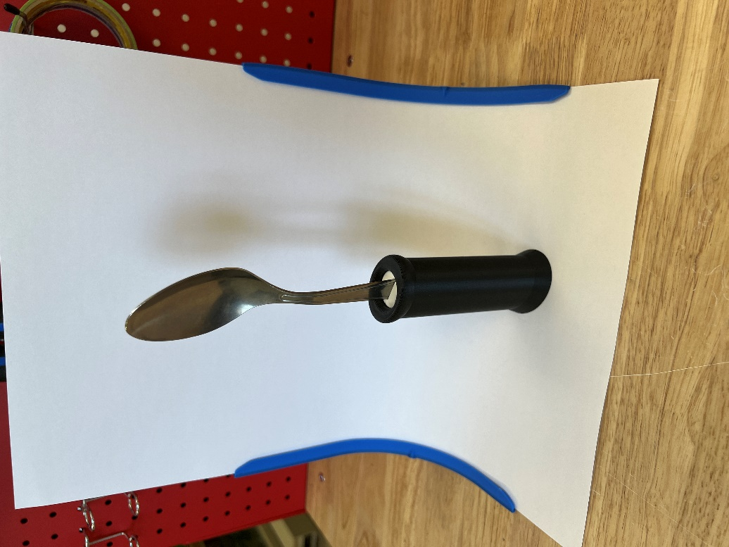 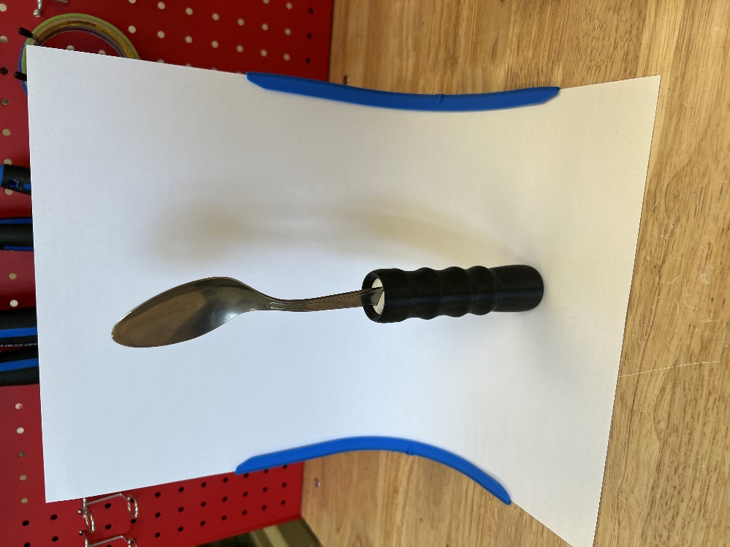 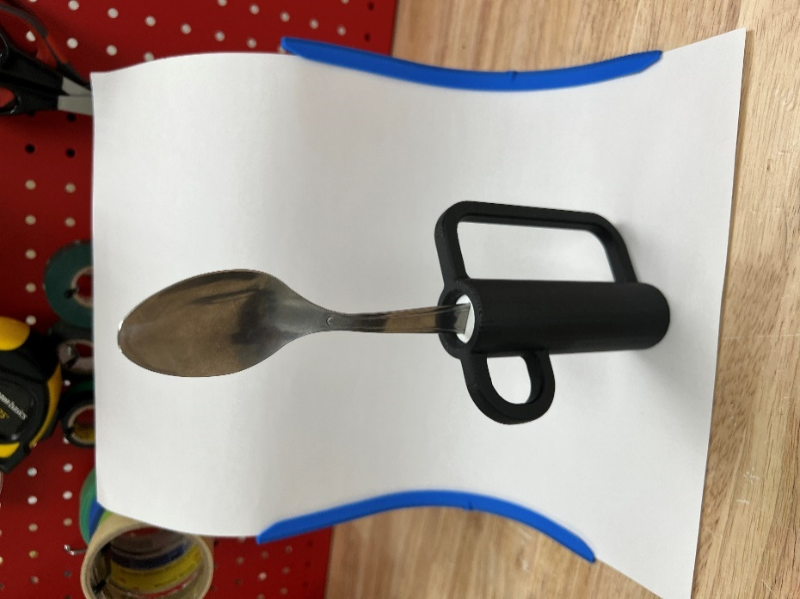 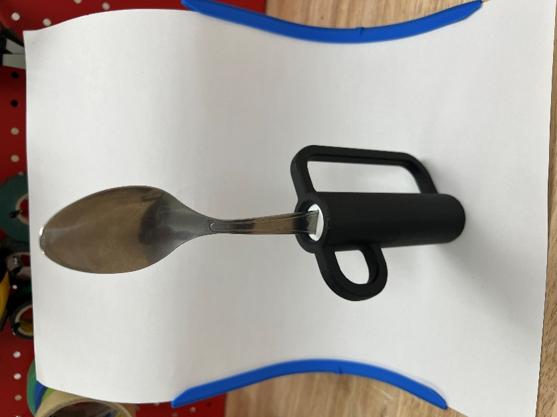

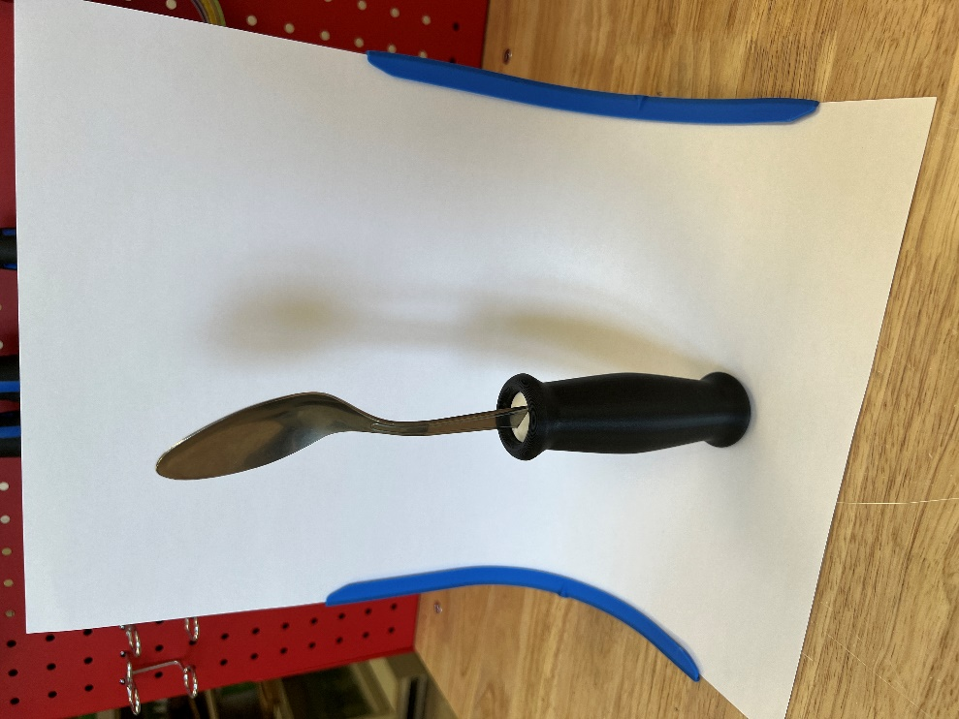 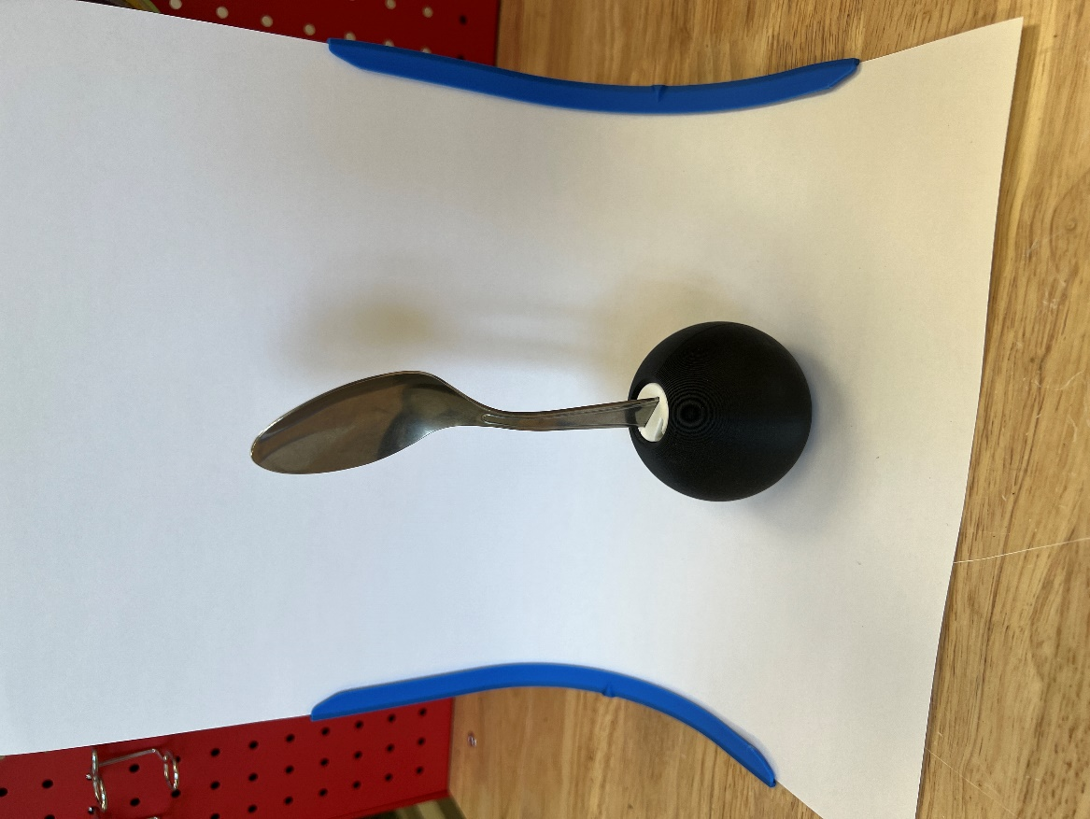 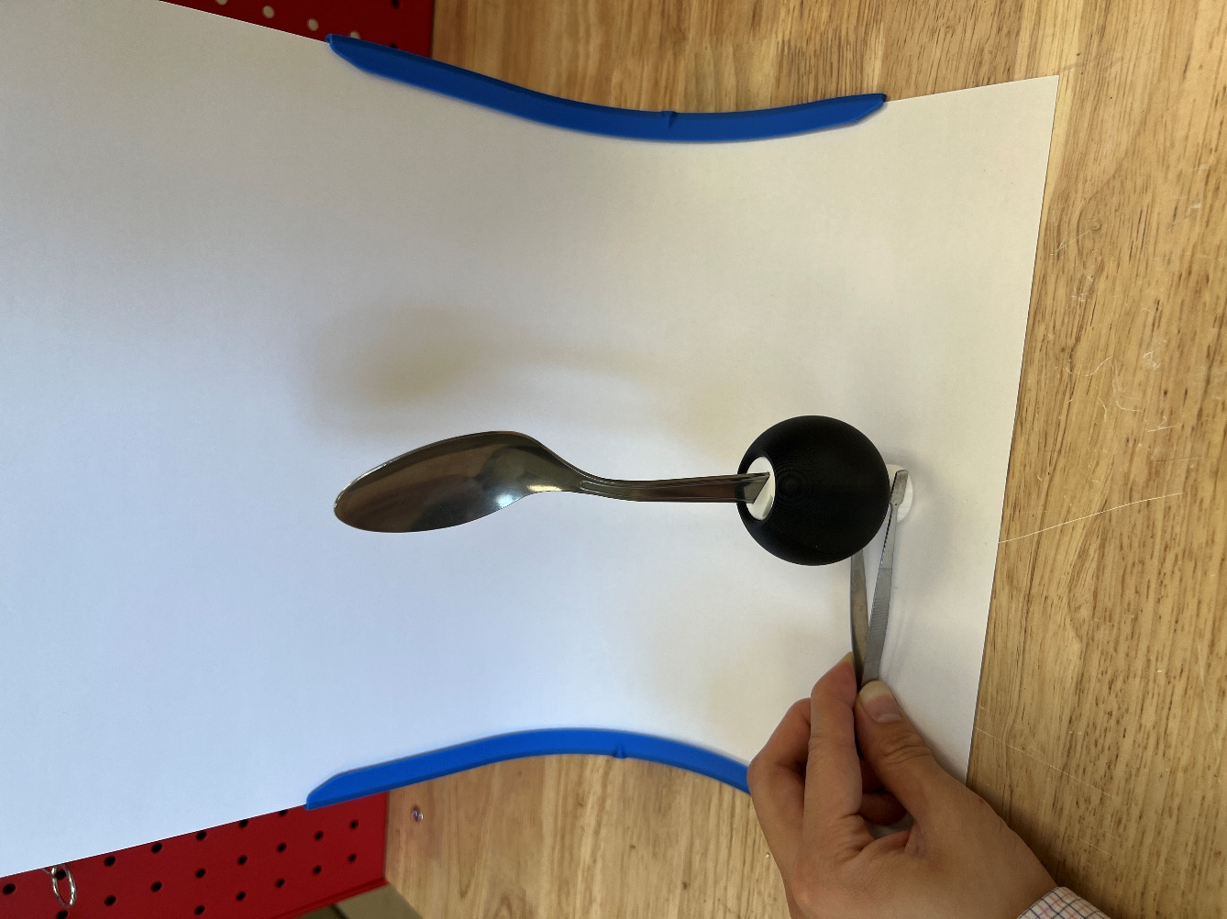 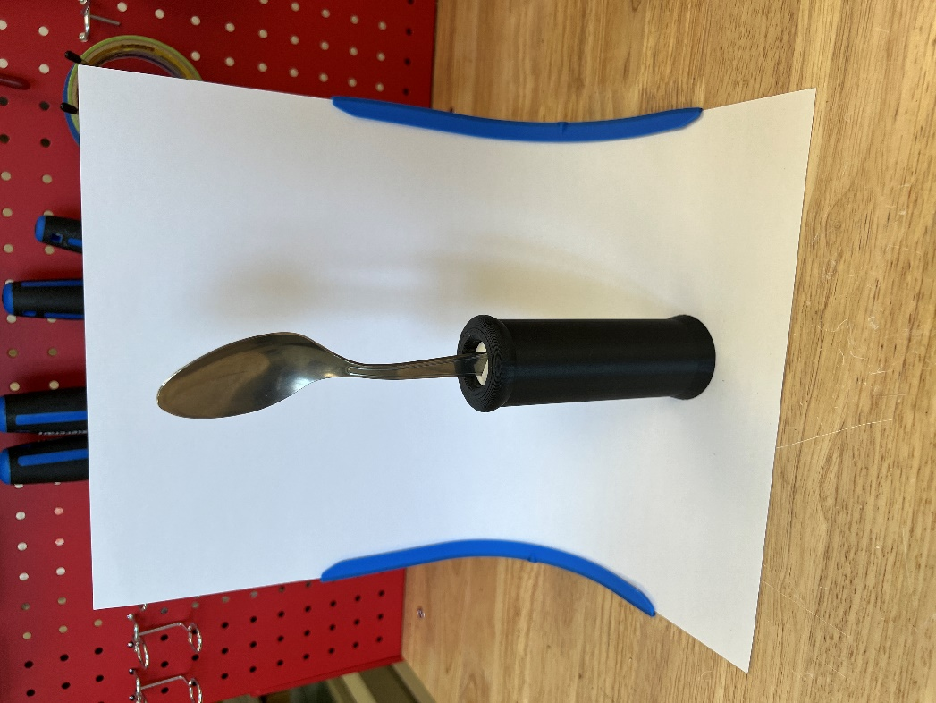 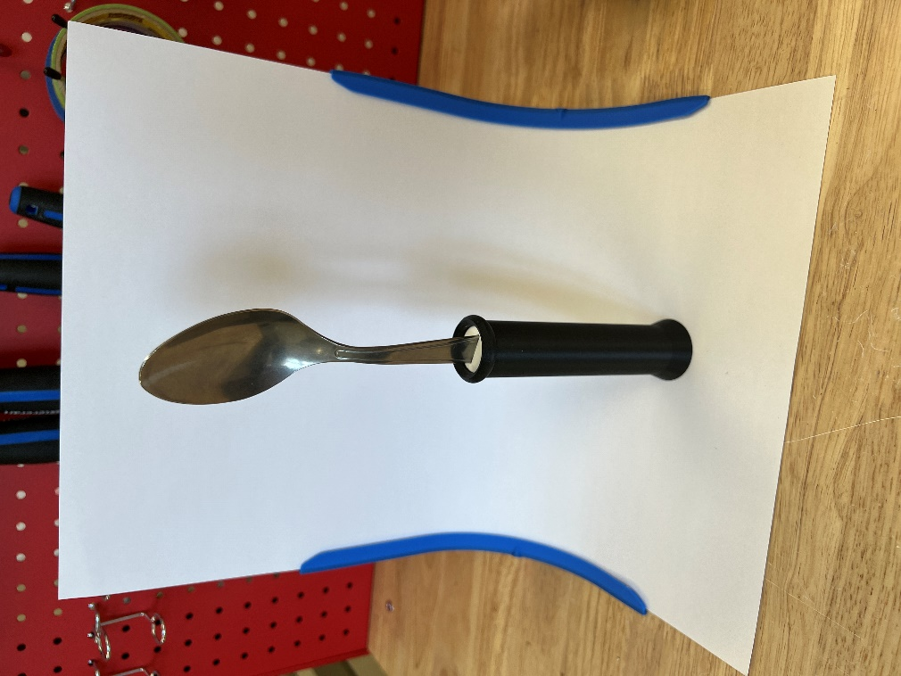

# Opportunities for Improvement

### Physical Component / Enclosure

There is one major handle shape that is not currently covered by the 9 handles: a universal cuff handle. Universal cuff adaptive utensils are available on common sites like Amazon, but few provide a larger handle to grip onto, and again, users are unable to test the handle before buying one. Some experimental designs were made for a 3D printed handle compatible with universal cuff straps made in the hospital, but this also does not solve the problem of a high-cost barrier to entry. In the future, a more cost-effective universal cuff handle can be designed to use more readily available strap materials such as generic fabric, hook-and-loop strips, or even 3D printed TPU.

Another area for improvement is the utensil compatibility. The 2 core models are currently only compatible with the IKEA IDENTITET large spoon and fork. IKEA is a widespread business, but there are still areas of the world that will not have easy access to IKEA products. And if the IDENTITET set is ever discontinued or undergoes design changes, then these 3D printed Adaptive Utensils will no longer be reproducible. As a preventative measure, further tests should be made to develop a core that is able to hold a wider variety of utensil handles. Doing this would further simplify the cores, as the different spoon and fork models could be consolidated as 1 file.